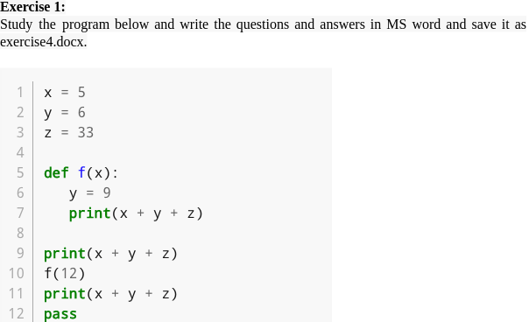

1. What is the output of the program?

44

54

44

2. Which line contains a function header?

Line 5

3. Which lines constitute the main program?

Lines 9 to 12

4. Is there a local variable defined anywhere? If so what is the scope?

Yes, on line 6. Its scope is to be used within the function.

5. Does the function of return a value?

Yes

6. Does the function of reference any global variables?

Yes, it references global variable z.

7. Which lines constitute a function body?

Lines 6 to Line 7

8. Are there any arguments used in the program? If so, what and where are they?

Yes, the argument is 12 on line 10. This is because an argument is a value that

Is passed when a function is called.

9. Are there any parameters defined in the program? Explain.

Yes, x is a parameter in the function f(x). This is because a parameter

Is the variable defined within the parentheses during function definition?

10. What does the last line do?

Pass is a null statement which is not ignored by the interpreter. Thus pass is

used at times as a place holder when the user does not know what to write next